CYBERSECURITY PROJECT

Vulnerability Assessment & Penetration Testing
Advanced Penetration Testing Engineer – Hands On
Batch 14

Name - Rashadul Islam
Email - rashad.cybersec@gmail.com
Kali Linux + Metasploitable 2 on Host-Only Network

SECTION A: VULNERABILITY ASSESSMENT
In this section, Nessus Essentials was used to scan Metasploitable 2, analyse the results, and produce a structured vulnerability assessment report. Weaknesses were identified without actively exploiting them.

VA Task 1: Configure and Run a Nessus Scan

Scan Configuration Details
Scan Name | Metasploitable2_VA_Scan
Target IP Entered | 192.168.56.101
Scan Policy Used | Basic Network Scan

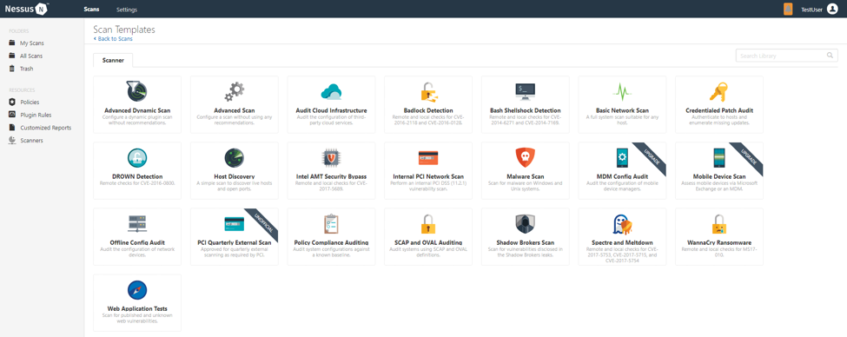

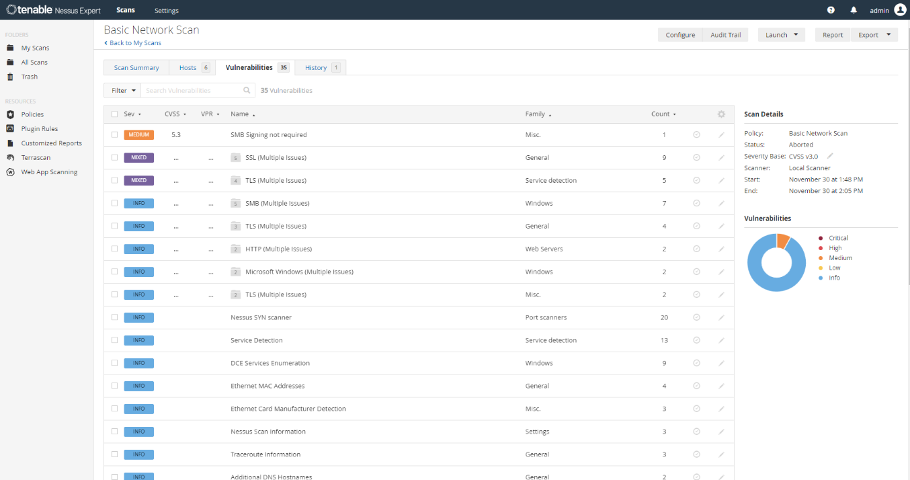

Nessus Scan Summary — Severity Counts
Critical | High | Medium | Low | Informational
8 | 14 | 22 | 5 | 31

VA Task 2: Analyse Nessus Findings

Critical/High Severity Finding
Vulnerability Name | vsftpd 2.3.4 Backdoor Command Execution
Severity Level | Critical
CVE Number | CVE-2011-2523
Affected Port / Service | Port 21 / FTP (vsftpd 2.3.4)
What does this vulnerability mean? | vsftpd version 2.3.4 contains a deliberately introduced backdoor in its source code. When a user logs in with a username containing the ':)' string, the server opens a root shell on TCP port 6200, bypassing all authentication.
What could an attacker do with it? | An attacker can exploit this backdoor to gain a root-level command shell on the target server without any valid credentials. With root access, they could steal all data, install persistent malware, pivot to other systems on the network, or completely take over the server.
Fix / Recommendation | Immediately upgrade vsftpd to the latest stable version (3.x or higher). The backdoor was removed in subsequent releases. Additionally, consider replacing FTP with SFTP (SSH File Transfer Protocol) which provides encrypted file transfers and eliminates this class of vulnerability.

Medium Severity Finding

Vulnerability Name | SSL Medium Strength Cipher Suites Supported (SWEET32)
CVE Number | CVE-2016-2183
Affected Port / Service | Port 443, 8443 / HTTPS / SSL
Brief Explanation | The target server supports SSL/TLS cipher suites using 64-bit block ciphers (e.g., 3DES). These are vulnerable to birthday attacks that allow an attacker to decrypt encrypted traffic after observing sufficient data.
Fix / Recommendation | Disable all medium-strength and weak cipher suites in the SSL/TLS configuration. Only allow strong ciphers (AES-128/256 with GCM) and upgrade to TLS 1.2 or higher.

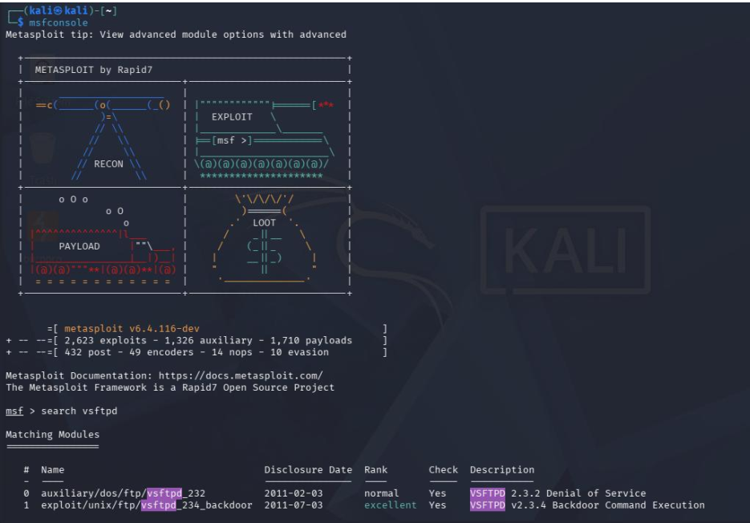

Open Ports and Services Detected
Port | Service | Notes / Nessus Comment
21 | FTP (vsftpd 2.3.4) | Contains backdoor CVE-2011-2523; allows unauthenticated root access
22 | SSH (OpenSSH 4.7p1) | Outdated SSH version; supports weak algorithms including arcfour
80 | HTTP (Apache 2.2.8) | Outdated Apache; hosts DVWA (Damn Vulnerable Web Application)
139/445 | SMB (Samba 3.0.20) | Vulnerable to username map script exploit; allows remote code execution
3306 | MySQL 5.0.51a | Accessible without password for root user; critical misconfiguration
5900 | VNC (protocol 3.3) | VNC running without authentication; allows full graphical desktop access

Difference between Vulnerability Assessment and Penetration Testing
A Vulnerability Assessment (VA) is a systematic process of identifying, classifying, and prioritising security weaknesses in a system or network without actually exploiting them. The goal of a VA is to produce a comprehensive list of known vulnerabilities, typically using automated tools like Nessus. so that an organisation understands its risk exposure. The output is a report of vulnerabilities sorted by severity, along with recommendations for remediation.

A Penetration Test (PT) goes a step further by actively attempting to exploit identified vulnerabilities in a controlled manner, simulating what a real attacker would do. A PT validates whether a vulnerability is actually exploitable in the context of the specific environment, determines the potential impact of a successful breach, and provides concrete evidence that a risk is real, not merely theoretical. While a VA answers "what could be wrong?", a penetration test answers "what can actually be broken and how far can an attacker get?"

SECTION B: PENETRATION TESTING
In this section, Metasploit Framework was used on Kali Linux to actively exploit a vulnerability identified in Section A on the Metasploitable 2 target system.

PT Task 1: Exploitation with Metasploit

Chosen Exploit: A — vsftpd 2.3.4 (FTP Backdoor) | Port: 21 | Module: exploit/unix/ftp/vsftpd_234_backdoor

Exploitation Steps
# | Command Typed | Output / What Happened
1 | msfconsole | Metasploit Framework console launched. Displayed the MSF banner with version information and module counts. The msf6 > prompt appeared.
2 | search vsftpd | Returned one matching module: exploit/unix/ftp/vsftpd_234_backdoor with rank 'Excellent'. The description confirmed it targets the vsftpd 2.3.4 backdoor.
3 | use exploit/unix/ftp/vsftpd_234_backdoor | Context changed to msf6 exploit(unix/ftp/vsftpd_234_backdoor) >, confirming the module was loaded and ready to configure.
4 | set RHOSTS 192.168.56.101 | Metasploit confirmed: RHOSTS => 192.168.56.101. The target IP was set to the Metasploitable 2 machine on the Host-Only network.
5 | run | Exploit initiated. Output: '[*] Banner: 220 (vsFTPd 2.3.4)', then '[+] Backdoor service has been spawned, handling...', and '[+] UID: uid=0(root) gid=0(root)' — a root shell was obtained.
6 | whoami | Output: root — confirming the shell is running with the highest privilege level on the target system (root / superuser). Full system control was achieved.

Screenshot: pt1_exploit_result.png — Shell prompt after running the vsftpd exploit showing root access

Exploit Outcome
The exploit succeeded on the first attempt. Metasploit connected to the FTP service on port 21, triggered the backdoor by appending ':)' to the username field, and a command shell opened on port 6200. The 'whoami' command immediately confirmed root-level access, proving the target was completely compromised without requiring any valid credentials.

Significance of Root Access
The shell was returned as root — the highest privilege account in Linux/Unix systems. This means there are no restrictions: the attacker can read, modify, or delete any file; add or remove user accounts; install backdoors or keyloggers; access password hashes; and pivot to other machines on the network using credentials stored on this host.

Post-Exploitation Commands
Command | What It Shows
uname -a | Displays the full Linux kernel version, hostname, architecture, and build date. Helps identify the exact OS version and whether kernel-level privilege escalation exploits are applicable.
cat /etc/passwd | Reads the system user account file, listing all accounts, their UIDs, home directories, and shell types. Reveals all accounts on the target, enabling further credential attacks or lateral movement.

Screenshot: pt1_post_commands.png — Output of uname -a and cat /etc/passwd in the root shell

PT Task 2: Penetration Test Report

Finding Report Card
Finding Title | vsftpd 2.3.4 Backdoor Remote Command Execution
Severity | Critical
Affected Service & Port | FTP (vsftpd 2.3.4) — TCP Port 21
CVE Number | CVE-2011-2523
What is the vulnerability? | vsftpd version 2.3.4 contains a deliberately planted backdoor. When an attacker sends a username containing ':)', the FTP daemon opens a root command shell on TCP port 6200. This allows anyone who knows the trigger to gain full administrative access without a password.
How was it exploited? | Using Metasploit Framework on Kali Linux, the module 'exploit/unix/ftp/vsftpd_234_backdoor' was loaded and the target IP was set. Running the module automatically triggered the backdoor. Within seconds, a root-level command shell was established, confirmed by 'whoami' returning 'root'.
What is the impact? | A real attacker could exfiltrate all sensitive data, install persistent malware or ransomware, destroy data and take the system offline, or use this server as a launching point to attack other systems within the organisation's network.
Evidence (Screenshots) | pt1_exploit_result.png — Root shell established pt1_post_commands.png — Post-exploitation commands va2_critical_finding.png — Nessus detection of the vsftpd vulnerability
Recommended Fix | 1. Immediately upgrade vsftpd to the latest stable version (3.x) — the backdoor was removed in later releases. 2. Replace FTP entirely with SFTP or FTPS for encrypted file transfers. 3. Implement firewall rules to block external access to port 21 and audit all FTP services on the network.

Executive Summary
A penetration test was conducted on the Metasploitable 2 server (IP: 192.168.56.101) to evaluate its security posture. The assessment revealed that the server is running an FTP service (vsftpd version 2.3.4) that contains a known backdoor — essentially a hidden door that any attacker on the network could use to gain full administrative control of the server without needing a password. During testing, this backdoor was successfully exploited in under two minutes, granting the tester complete 'root' (administrator) access to the entire system.

With this level of access, a malicious attacker could steal all data stored on the server, install software to spy on users, encrypt files for ransom, or use the server as a stepping-stone to attack other computers in the organisation. This represents the highest possible risk level (Critical) and requires immediate action. It is strongly recommended that the FTP service be upgraded or replaced with a secure alternative (SFTP) as an emergency priority, and that a comprehensive security review of all systems on the network be conducted without delay.

— END OF PROJECT SUBMISSION — BATCH 14 | ADVANCED PENETRATION TESTING ENGINEER —

